
Department of BES-1
DATA STRUCTURES USING PYTHON
I-B.Tech-(II Sem), Academic Year: 2024-2025

Session-3 Insertion Sort
Aim:
To familiarize students with the basic concept of Insertion Sort and Shell Sort

Instructional Objective:

This Session is designed to:
- Demonstrate Insertion sort
- Describe sorting technique work
- List out the steps of the sorting algorithm

Learning Outcomes:

At the end of this session, you should be able to:
- Define Insertion Sort
- Describe algorithm and complexity of Insertion Sort
- Summarize Insertion Sort

Introduction:
Insertion sort is a simple sorting algorithm that works similar to the way you sort playing cards in your hands. The array is virtually split into a sorted and an unsorted part. Values from the unsorted part are picked and placed at the correct position in the sorted part.
Characteristics of Insertion Sort:
• This algorithm is one of the simplest algorithm with simple implementation
• Basically, Insertion sort is efficient for small data values
• Insertion sort is adaptive in nature, i.e. it is appropriate for data sets which are already partially sorted.
On average to place the k^{th} element into its correct position it requires (k+1)/2 number of comparisons. If from an array of size n we want to place the 5th element into its proper position then (5+1)/2 = 3 number of comparisons are required
Let us understand Insertion sort with the help of some example.
Consider an example:
arr[]: {12, 11, 13, 5, 6}
The array contains 5 elements in random order. Now pass-by-pass we will observe the status of the array to understand the working principle of the algorithm.

12 | 11 | 13 | 5 | 6

First Pass:
Initially, the first two elements of the array are compared in insertion sort.

12 | 11 | 13 | 5 | 6

Here, 12 is greater than 11 hence they are not in the ascending order and 12 is not at its correct position. So we will swap 11 and 12.
So, for now 11 is stored in a sorted sub-array.

11 | 12 | 13 | 5 | 6

Second Pass:
Now, let us move to the next two elements and compare them.

11 | 12 | 13 | 5 | 6
Here, 13 is greater than 12, thus both elements seems to be in ascending order, hence, no swapping will occur. 12 also stored in a sorted sub-array along with 11
Third Pass:
Now, two elements are present in the sorted sub-array which are 11 and 12
Moving forward to the next two elements which are 13 and 5.
11 | 12 | 13 | 5 | 6

Both 5 and 13 are not present at their correct place so swap them.
11 | 12 | 5 | 13 | 6

After swapping, elements 12 and 5 are not sorted, thus swap again.
11 | 5 | 12 | 13 | 6

Here, again 11 and 5 are not sorted, hence swap again.

5 | 11 | 12 | 13 | 6

Here, it is at its correct position.
Fourth Pass:
Now, the elements which are present in the sorted sub-array are 5, 11 and 12
Moving to the next two elements 13 and 6.

5 | 11 | 12 | 13 | 6

Clearly, they are not sorted, thus perform swap between both.

5 | 11 | 12 | 6 | 13

Now, 6 is smaller than 12, hence, swap again.

5 | 11 | 6 | 12 | 13

Here, also swapping makes 11 and 6 unsorted hence, swap again

5 | 6 | 11 | 12 | 13

Finally, the array is completely sorted.

5 | 6 | 11 | 12 | 13

Execution example of Insertion sort-
The following example of insertion sort algorithm will give a clear picture of working principle of the algorithm.
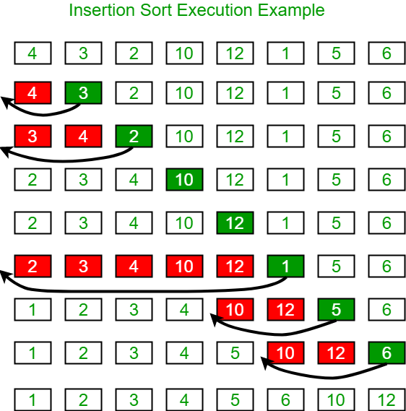

Algorithm
The simple steps of achieving the insertion sort are listed as follows -
Step 1 - If the element is the first element, assume that it is already sorted. Return 1.
Step2 - Pick the next element, and store it separately in a key.
Step3 - Now, compare the key with all elements in the sorted array.
Step 4 - If the element in the sorted array is smaller than the current element, then move to the next element. Else, shift greater elements in the array towards the right.
Step 5 - Insert the value.
Step 6 - Repeat until the array is sorted.

Complexity of Insertion sort-
- Best Case Complexity - It occurs when there is no sorting required, i.e. the array is already sorted. The best-case time complexity of insertion sort is O(n).
- Average Case Complexity - It occurs when the array elements are in jumbled order that is not properly ascending and not properly descending. The average case time complexity of insertion sort is O(n²).
- Worst Case Complexity - It occurs when the array elements are required to be sorted in reverse order. That means suppose you have to sort the array elements in ascending order, but its elements are in descending order. The worst-case time complexity of insertion sort is O(n²).

Summery:
- This algorithm is one of the simplest algorithm with simple implementation
- Basically, Insertion sort is efficient for small data values
- Insertion sort is adaptive in nature, i.e. it is appropriate for data sets which are already partially sorted.

Self-assessment questions:

- How many passes of insertion sort do we need to give for an array of size n to sort?
  - n
  - n+1
  - n-1
  - (n+1)/2

- What is the complexity of Insertion sort in worst case scenario?
  - O(n)
  - O(nlog n)
  - O(n2)
  - O(2n log n)

Terminal questions

- Describe what is insertion sort.
- List out the steps involved in insertion sort.
- Analyze the complexity of insertion sort.
- Summarize the working principle of insertion sort.

Practice Problems
Given a list of N array elements apply insertion sort on array.
Input Format
The first line contains the integer N, the size of
the array. The next line contains N space
separated integers.
Constraints
- • 1<=N<=1000
- • -1000<=a[i]<=1000
Output Format: Print the array as a row of space-separated integers each iteration.
REFERENCES FOR FURTHER LEARNING OF THE SESSION:

Reference Books:
- Data Structures and Algorithm Analysis in PYTHON, 2010, Mark Allen Weiss, Second Edition, Pearson Education.
- Data Structures and Algorithms, A.V.Aho, J.E.Hopcroft, and J.D.Ullman, Pearson Education, First Edition Reprint2003.
- Advanced Guide to Python 3 Programming, John Hunt, 4th Edition, Springer Nature Switzerland AG 2019.
- Python Basics: A Practice Introduction to Python 3, David Amos, Dan Bader, Joanna Jablonski, Fletcher Heisler, 4th edition, Real Python.

Sites and Web links:
  - https://docs.python.org/3/tutorial/datastructures.html
  - https://www.w3schools.com/dsa/dsa_intro.php
  - https://www.geeksforgeeks.org/python-data-structures/
  - https://onlinecourses.nptel.ac.in/noc25_cs59/preview
  - https://www.coursera.org/learn/python-data
  - https://www.codecademy.com/learn/learn-data-structures-and-algorithms-with-python

